Parallel Programming Assignment Report Template

Students Information
Student Name: samer saad / Mena magdy / Abanoub hashmet / Bassem adel

Problem Information
Problem Title: Pi Calculation with Race Condition
Lecture Number: 2

Problem Description
Calculate PI using numerical integration with multiple threads.
π=∫ 4.0 / (1.0 + x * x) ​dx

Parallelization Approach
1- The loop is parallelized using OpenMP

Solution Explanation
- All threads update the shared variable pi simultaneously

Source Code
- 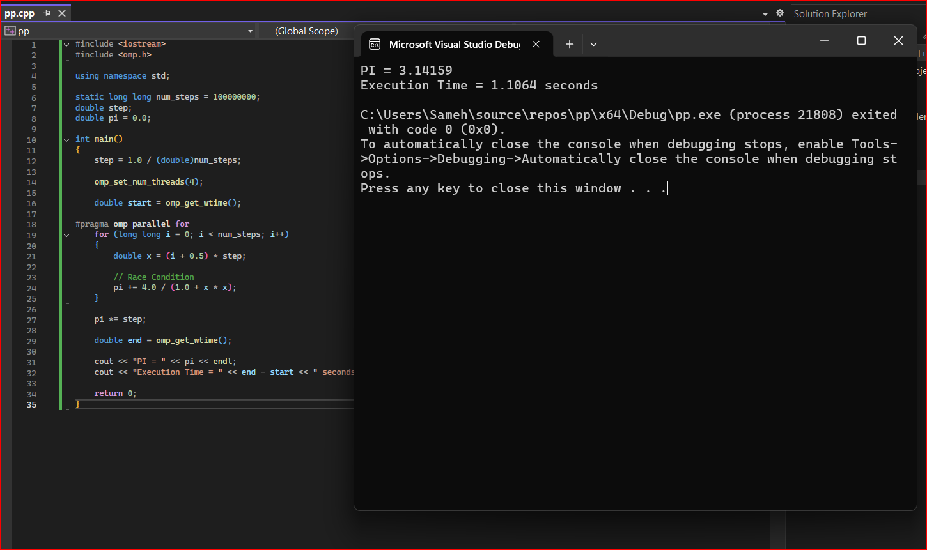

Execution Results

PI = 3.141592653589

Execution Time =like 1.11609 seconds
Conclusion
The parallel implementation significantly reduces execution time. Race conditions are eliminated.

